Cultural tools as mediators of mathematical cognition:
Iron and bamboo compasses of the Torajan woodcarvers of Sulawesi
Miquel Albertí and Núria Gorgorió

This paper is concerned with the compasses of the Torajan woodcarvers of Sulawesi. One of these artefacts, the bamboo compass, shares with the standard western compasses the purpose for what both of them were constructed: to draw circumferences. But its physical characteristics and the way it is used embed mathematical ideas different from those embedded in the western compass’ characteristics and use. Such differences show that the relationship between artefact and cognition cannot be detached from the context. In any activity, tools play a fundamental role besides the practical use: they are cognitive mediators. They are agents both of mathematical ideas related to their physical characteristics and of mathematical ideas encompassed in the way they are used. Thus, tools become paths leading towards their users’ minds. Tools used in a particular situation are a critical aspect of the situation itself and, at the same time, their use may suggest relevant questions concerning mathematical cognition. Our main purpose is common to both ethnomathematics researchers and socio-cultural psychologists interested in out-of-school knowledge, for it deals with the legitimisation of non-western, out-of-school mathematical ways of knowing.

Artefacts and cognition
Ethno-mathematics researchers, concerned with historical and anthropological analysis of the mathematics of different socio-cultural groups, and psychologists interested in the study of the psychological processes involved in learning and using mathematics in specific socio-cultural contexts are concerned with the same phenomena at different levels of analysis, both demanding the legitimacy of the forms of knowledge associated with out-of-school practices (Abreu, 1998). Albertí (this same book) presents his identification and characterization of the mathematical knowledge among the practices of Torajan woodcarvers in Sulawesi. In this paper, we discuss how certain cultural tools and the way they are used by the woodcarvers act as mediators not only in the ways people deal with their practice, but also in their thinking.
For the purpose of this paper, we will use the words ‘artefact’ or ‘tool ’ to refer to physical objects that allow artisans to give shape to the product of their activity, like rulers or compasses. We will not refer to symbolic systems like counting systems or symbolic notation. Artefacts are essential for the development of their practice and allow them to solve problems, of an everyday character, socially relevant to their community. Tools allow their users to achieve their goals satisfactorily, according to the cultural and social standards of their groups. ‘Socio-cultural history provides tools for cognitive activity and practices that facilitate reaching appropriate solutions to problems’ (Rogoff and Lave, 1984: 4). We understand the woodcarvers’ tools to be socio-cultural products, since they have been developed and adapted to their particular purposes, by a group of people with a particular and shared understanding of the world.
Artefacts have a significant role within the community that uses them, both socially and culturally. ‘Tools are the basis for carrying out the socially organized activity which, is, in turn, the basis for the development of new mental functioning and activity in the world’ (Clancey, 1995). Artefacts are cultural products which have an effect of utmost importance on their users’ cognitive and cultural development. Moreover, tools allow and shape the continuity or evolution of a particular way of understanding the world. According to Abreu: ‘There is no doubt that tools are one of the most important aspects of the macro-context and need to be taken into account in order to understand actions in micro-contexts’ (Abreu, 2000: 4).
Since the late 80’s many developmental psychologists have shown a growing interest in the study of cognition as activity in socio-cultural contexts (Cole, 1995; Lave, 1988; Saxe, 1990; Rogoff, 1990; Werstch, 1991). Despite not having a single definition of context, such studies can be seen as dealing with the cultural component of the context or with its social component. The fact that local cultural resources, such as drawing or measuring artefacts, articulates carvers’ thinking can be interpreted as Vygotsky’s (1978) view of cognition as mediated by cultural tools. Research on the cultural aspect of context has shown how cultural tools mediate cognition. Some authors even consider that this mediating role has become a ‘hallmark of situated theories of cognition’ (Resnick, Pontecorvo and Säljö, 1997).
The subject of this paper has to do with one of the units of analysis pointed out by Engeström and Cole (1997) concerning practice: the mediated action. The idea of mediated action was developed by Wertsch (1995) and other colleagues for the analysis of sociocultural research. The agents of actions are conceived as ‘individuals-operating-with-mediational means’, mediational means which conform mental functioning and action being a characteristic aspect of a sociocultural setting (Wertsch, 1995: 64). Individuals and mediational means are the focus in our approach, since we are concerned with the way they interact with each other, that is, how practical tools or artefacts mediate their users’ mathematical cognition and how users’ thinking conditions the decisions about wether to use or not certain artefacts.
By analysing the physical features of a tool, why a tool is constructed, what it is used for, how it is mastered by individuals, what are the products of its use and how it is used, we are approaching the tool users’ minds: ‘the analysis of specific tools for representing mathematical ideas provides a very useful insight into the way tools structure the way a person thinks’ (Abreu, 2000: 6). Abreu (op. cit.) also presents a possible way to structure the analysis of tools as mediators of cognition. From the perspective of the cultural component of context, she suggests analysing the different ways a) cultural tools are organised logically; b) specific tools constrain learning and problem solving; c) specific social practices constrain the use of certain tools; and d) old tools are used in new contexts.
For the rest of the paper we discuss those aspects in relationship to the use made by Torajan woodcarvers of different compasses available to them to exemplify how context structures the way people think and use knowledge.

The research context
The context of this paper is that of the Torajan woodcarvers of Sulawesi, in Indonesia. Torajan culture is characterized by particular features very distinct from those of its Bugis neighbours, also living in the south west peninsula of Sulawesi island.
Torajan culture is based on the cult of their ancestors and in a cosmogonist vision of the world in halves and binary opposite sections, like life and death, male-female, heaven-earth. The traditional houses and rice-barns are constructed in order to reflect these conceptions (Nooy-Palm, 1988). This makes Torajan Architecture one of the most visible means to identify the culture: you know you are in Toraja Land as soon as you start seeing the impressive and particularly ornamented buildings (Sandarupa, 1986). Torajan houses, made of wood, always face north, while rice-barns, in front of them, face the house, looking to the south. In both cases, the façades are divided in sections where ornamental designs are carved. Every carved design has a socio-cultural meaning and is named according to what it resembles, usually geometric abstractions of plants. Places of great cultural and social significance, such as wooden doors and coffins for the deceased, are also carved as many objects to supply the tourist industry of the area are.
Torajan designs are not carved in wood panels on a horizontal surface, but carved on the already assembled wood pieces that constitute the façades of the house or rice-barn. Thus, the work develops in vertical planes, and the shape of the space to be carved is determined, most of them being rectangular. As the coffins have convex surfaces, the designs carved on them are no longer flat. This is also the case for the cylindrical recipients which are sold as souvenirs. In any case, the carving process follows a systematic procedure where different tools are used. One of them will be our object of study here: the bamboo compass.

Compasses of the Torajan woodcarvers
What is a compass? What do you use it for? Surely, it is used to draw circumferences and arcs and, probably, to draw the median line of a segment. What else do you think a compass could be useful for? When trying to find the possible answers to these questions, all of us, belonging to a western culture, have in mind a compass. In fact, we think of the western standard metal compass, an object that the Oxford dictionary defines as ‘an instrument for drawing circles and arcs and measuring distances between points, consisting of two arms linked by a movable joint’ (Pearsall, 1999).
In a western compass, the two arms have a different end, one ending in a nail, the other in a pencil. The first serves to fix the instrument on a location becoming the centre of the drawn arc or circumference; the second creates a line on the surface when the whole artefact is turned around the other fixed end. The invisible segment between both arms’ ends determines the radius of the traced circumference. This circumference arises from the movement in the three dimensional space of a virtual triangle established by this imaginary segment and the two arms. One of these arms will very rarely be the axis of rotation of the whole artefact as this will only happen when the nailed arm is perpendicular to the surface, the other pencilled arm being longer than this.
But, have you ever measured anything with a western compass? If so, what was the result of the measure? Compasses are not rulers. Some of them have an added curved, piece marked with degrees divisions, where you can read the measure of the angle opened between both arms. But compasses don’t measure lengths. What the dictionary means is that a compass can be used to take a distance, that is, the length of a segment, and place it in another location. This is the Euclidean use of a compass.
Until this point, the western standard compass characteristics have been described without any visual support, only verbally. It will be easily noticed how many mathematical ideas are necessary to produce a precise description of this artefact. The dictionary definition of a compass focuses on two fundamental aspects of any tool: its physical description and its use. We may always have a linguistic definition of any tool, but we believe that the concepts and ideas generated by using it constitute the most important aspect of the tool.
What would you think a bamboo compass is? The word ‘compass’ may probably lead your thoughts to the standard western metal compass, which you may now imagine as made of bamboo, maybe with its arms tied with a string. What would you think if you were told that the bamboo compass is used to draw circumferences and that it is compounded of three pieces, one of them a nail? The product of the compass, a circumference, and the ‘nail’ are other coincidences with the compass you may have in mind. Probably, you’ll think the nail is used to situate the centre of the circumference to be traced. And what would you think if you were told that a bamboo compass has two arms? Surely you would think, as any westerner would do, that it’s a bamboo version of the standard compass you already know.
A bamboo compass consists of three elements: a bamboo stick, a nail and a pencil. But it would be quite difficult to visualize how such pieces could be arranged in a compass if you haven’t had the opportunity to see how such a tool is used.
The bamboo compass is created when a small straight bamboo stick is knocked into a wall through one of its ends. Then, introducing the tip of a pencil through a hole made in the stick and pushing to the left or right, an arc of circumference is traced (see illustration 1 below).
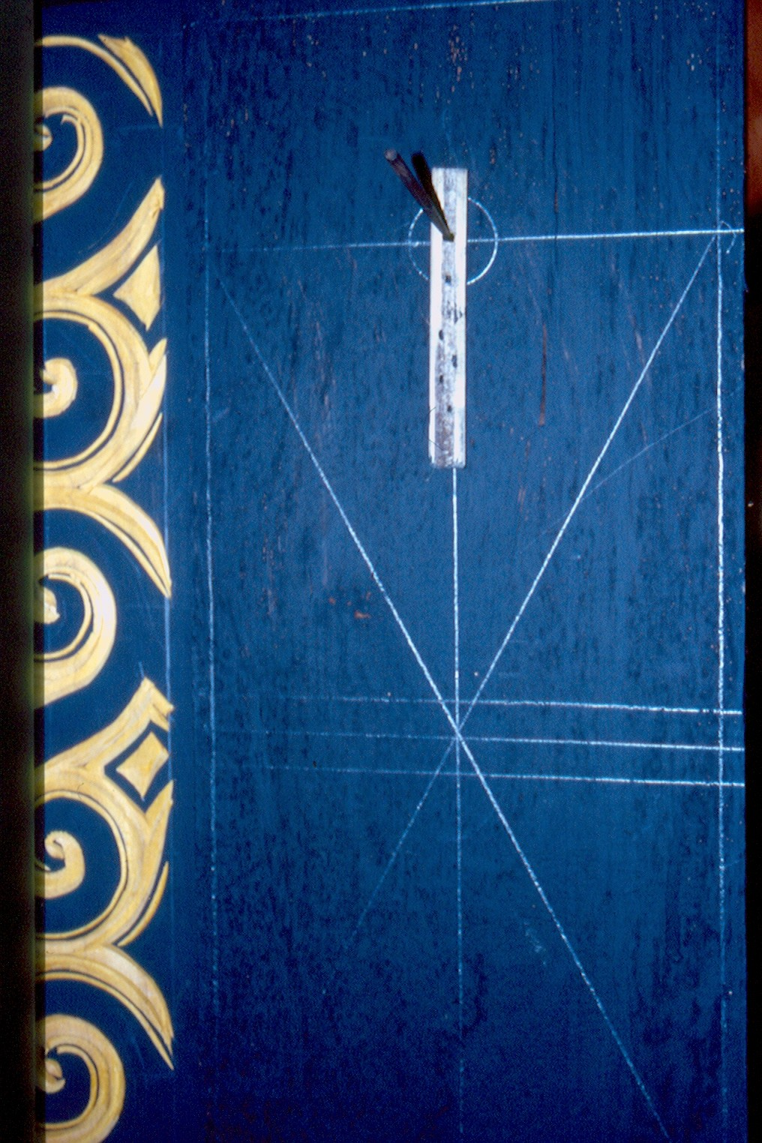
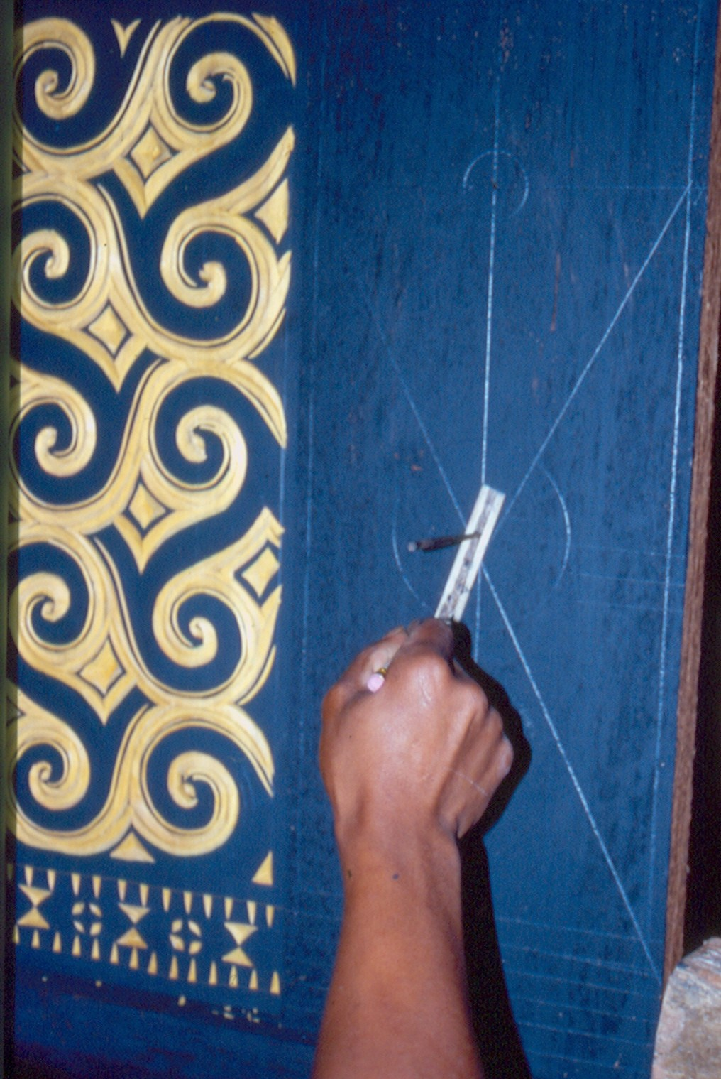
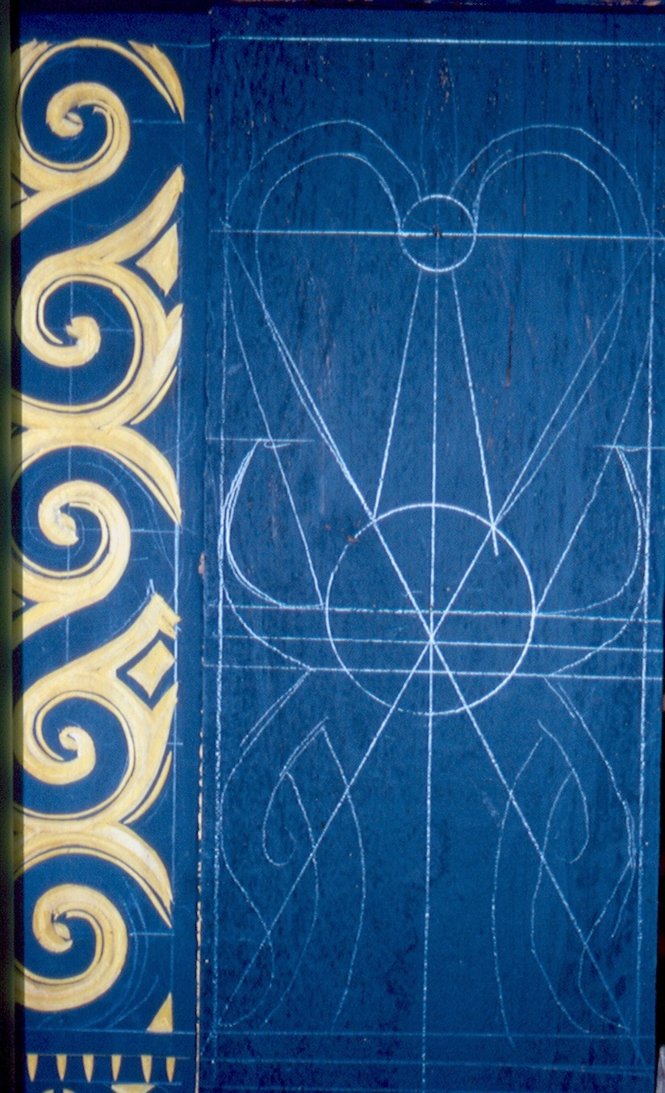

Illustration 1: Torajan carver using the bamboo compass.

The bamboo compass fits the western dictionary definition of a compass: it has two arms (the bamboo stick and the pencil) with a ‘movable joint’ and it’s used to draw arcs and circumferences. If we look for a definition of a compass in a mathematical dictionary we find: ‘Drawing instrument which allows the tracing of circumferences and, overall, move distances’ (Bouvier and George, 1984). The bamboo compass also verifies the first part of this definition, but no the second. The bamboo stick in itself is used to move distances, but this is not the case for the bamboo compass (Albertí, 2005). This artefact is much more than a single stick as it is a set of three elements: a nail, a drilled bamboo stick and a pencil. As the main characteristic of the western dictionaries’ definitions is that a compass is made to draw circumferences and as the Torajan woodcarvers also call such a tool a compass, we’ll do so as well.
Then, if it is a compass, what differences has it from the standard one? There are two main differences. First, the radius of the standard compass is invisible, implicit, while, on the contrary, it is visible and explicit, in the bamboo one. And second, if the angle between both arms of the standard compass is changed, then the circumference traced also changes, but the circumference drawn with a bamboo compass remains the same after changing the angle between both of its arms (see fig.1).
Figure 1: Embedded triangles in bamboo (left) and standard (right) compasses.
bamboo stick=radius
Pencil
plane surface
radius
A
A
‘movable joint’

Torajan woodcarvers also use a modified version of the western standard compass. Like its original it’s made of metal and manufactured in industries outside the region by standard western technologies, but it differs from it in that both of its arms end with nails. Therefore, either of its nail ends can be the centre of the circumference. The circumferences traced with this compass are not anymore ‘drawn’, but scratched on the surface. This property of shifting centres seems to be the main reason why a carver used an old oxidized pair of scissors as a compass. Oxidization is characteristic of all metallic compasses used in the region and what makes it valuable is that oxidized compasses become difficult to open or close, which means that a chosen radius will not easily be lost.
Chart 1 summarizes the main aspects of these three artefacts. For simplification we consider the compass with two nails as a standard one.

TORAJAN COMPASSES | Physical characteristics | What it is used for? | Use characteristics
Standard compass  (pencilled or nailed) | -Two arms.  -Collapsible. | -To draw circumferences.  -To take lengths.  -To divide a segment into equal parts: the Kira-kira method. | -The nailed end is the centre of the circumference.  -Embeds a triangle.  -Invisible radius.  -Variable radius.  -Variation of the angle of its arms implies a variation in the result.
Bamboo Compass | -Two arms.  -Non collapsible. | -To draw circumferences. | -Embeds a triangle.  -Visible radius.  -Fixed radius.  -Variation of the angle of its arms doesn’t imply any variation in the result.
Chart 1: Compasses of the Torajan wood carvers.

These tools are not used on horizontal but vertical wooden surfaces of the traditional Torajan houses and rice-barns. More than that, they are also used to decorate the convex surfaces of cylindrical objects like bamboo receptacles or the coffins for the deceased. All these compasses produce the same result: a circumference. This is the main reason for using them, but not the only one. The standard compasses are also used by Torajan carvers to do something very different from the purpose they were created: they are used to divide a segment into equal parts following the method named Kira-kira (Albertí 2005, also in this book). This role has no counterpart in Western culture. Western use of a compass includes its being involved in the division of a segment into two parts, but in an Euclidean process, not in a recursive one as is the case with the Torajan standard compass. An interesting question arises: is the standard compass kira-kira method to divide a segment into equal parts an adapted version of the bamboo stick’s kira-kira or is it the contrary?

Torajan compasses and cognition
To make clear the cognitive aspects related to Torajan compasses we address the four aspects pointed out by Abreu (2000) that we have already mentioned.

- Cultural tools logical organization
What is actually done by someone using a standard compass is turn a virtual triangle around an implicit and (almost always) invisible axis of rotation. This was already stated above when the western standard compass was described as a tool. Now we develop this issue further.
When this kind of compass is properly used an isosceles triangle is erected on the plane, its distinctive angle determining the length of the radius. The plane which contains this erected triangle will not necessarily be perpendicular to the plane which contains the circumference, and the circumference obtained would (theoretically) be the same even if it was lying on the plane. Actually, and for the benefit of an easy mastering of the tool, this triangle, that is, the compass, will be handled with some inclination. Otherwise it would be difficult to turn the compass, given the actions of the thumb, the forefinger and the full hand on it.
Calling O the point where both arms of the compass meet, two different actions can be distinguished in tracing a circumference. The first case (fig.2, left) is the most usual and corresponds to the proper use of this artefact. The whole tool has to be rotated, the point O describing itself a circumference distinct from that traced by the pencilled end of the compass.
In the second case (fig.2, right side), the nailed arm of the compass becomes the rotation axis and the point O describes the smallest of all possible circumferences, that is, a point. Thus, this point O is the centre of the tool’s rotation. But this happens only if the nailed arm is kept perpendicular to the plane, the other arm being longer than this one.
diameter
radius
Compass’ rotation axis
Plane surface
diameter
radius
Compass’ rotation axis
O
O
Figure 2: Horizontal view of active standard compass.

When using a bamboo compass the pencil is introduced through a little hole made close to one of its ends, while the other end is fixed with a nail. To draw an arc of a circumference the pencil must be moved around together with the bamboo stick, the radius. So the curve is traced on the wood as if it were drawn on paper. Similarly to what happens with the other compasses, it is not necessary to keep the pencil perpendicular to the plane or surface where the circumference is constructed. Some inclination will provide the same result, although only to a certain extent, otherwise the pencil tip will escape from its place (see fig.3).
Figure 3: Horizontal view of an active BC.
radius
Compass’ rotation axis
Plane surface
nail
Pencil

The bamboo compass has two particular characteristics not shared with the other compasses: its visible radius and its non collapsible character. From this very characteristic of a visible radius we can state that the definition of circumference, as ‘the geometrical locus of the equidistant points to a given one taken as its centre’, is not only appropriate to this tool, but is also the description of its product.
This relationship between the tool’s product and its definition is closer in this compass than in the standard one. In the latter the radius is invisible and what is actually turned is not the radius, but a triangle in the three dimensional space. Using a bamboo compass one can see and do the essential of what has to be conceived. On the one hand, one can see a circumference emerging from a set of points which are all at the same and fixed distance (given by the bamboo stick length) from another fixed one (given by the nail). On the other, one can see how the users’ hand ‘encompasses’ the radius creating the circumference.
Euclidean compasses are collapsible, every time you take them out from their place their arms may close. This is not the case for the bamboo compass, which is not an Euclidean tool. This non collapsibility makes it a proper artefact to be used when many copies of the same circumference have to be produced at different moments. On the walls of a rice barn (like the one in Illustration 1), around 20 designs, called Pa’ Tedong, based on the same circumference have to be carved. Once a radius is chosen for the first one, it is taken for the rest. Only some of them will be made during the same day. Completing the work can take days or weeks. The radius in the bamboo stick will last forever!
Moreover, the radius taken in the bamboo compass is a segment being always perpendicular to the line the pencil is tracing at each moment. And as the bamboo stick is, in fact, a small rectangle, its edge next to the pencil is also a small visible segment always parallel to the line the pencil is tracing. Therefore, not only the radius is visible, but also the perpendicular and the parallel to each small fragment of the traced curved line (see fig.4). Both perspectives embed the relationship of the circumference with the tangent and perpendicular in each of its points, invoking in this way the ideas of evolving and evolute curves.
pencil
nail
arc
centre
Perpendicular to the radio.

Parallel to the curve.

Figure 4: Zenith view of an active bamboo compass.

- Specific tools constrain or empower problem solving
The nailed standard compass is also useful for a specific task which is not performed by Torajan woodcarvers. Despite the fact that there is no Torajan carving based on a system of circumferences each of them passing through the centre of its neighbour, we mention it here to illustrate how a certain task may be easy or difficult depending on the tool which is used to perform it. When such a system of circumferences is to be drawn, the property of shifting centres becomes quite useful in practice because it allows the drawing of two of such circumferences ‘at once’, just by shifting the roles of both nailed ends. The starting point (X) and closing point (Y) of a circumference of centre in O become the centre (X=Y) of the next circumference with the same radius r starting and finishing in O (fig.5).

Figure 5: Two circumferences drawn ‘at once’.
O
X=Y
r
r

As already stated, there is no carving with such a geometric scaffolding, but with a nailed compass one would not need to think which was the end to take as the centre and one would not need to worry about breaking the pencil tip or it working loose.
Another issue of interest is that the bamboo compass produces true circumferences on convex surfaces. The bamboo stick is flexible, the longer the more flexible. When used on the convex surface of a coffin or a receptacle a true circumference comes out (fig.6). This is not the case for the other compasses.
Standard compass’s radius becomes virtual.
Bamboo compass’ radius is still true .
a
r=a
r
R
a_{M}
a_{m}
R
R
Figure 6: Standard and bamboo compasses acting on convex surfaces.

When used on a convex surface of radius R, standard compass with radius r does not create a circumference on the surface, but a closed curve with actual radiuss a_{m}=r (the shortest) and a_{M}=R·arcsin[r/(2R)] (the longest). On the contrary, a flexible bamboo stick of length r will always create a circumference of radius r on a slightly convex surface. Chart 2 summarizes the Torajan compasses’ mathematical cognitive analysis.

Tools | Observable facts | Related circumference conceptions on the plane
Tools | Observable facts | Direct | Indirect
Standard compasses  (pencilled or nailed) | -Invisible radius as the implicit side of a triangle. | -Set of points determined by the vertex of the side of a triangle turning around its other fixed end. | -Set of points equidistant to another fixed one.
Bamboo Compass | -Radius always visible as a segment turning around one fixed end.  -Radius as a segment always visible and always moving perpendicularly to the line the pencil is tracing.  -Edge of the bamboo stick as a small segment always visible and always moving parallel to the line the pencil is tracing. | -Set of points equidistant from a fixed one. | -The line always perpendicular to a given segment turning on one of its ends.  -Circumference related to the tangent and perpendicular in each of its points, thus evoking the ideas of evolving and evolute curves.
Chart 2: Torajan compasses and cognition.

- Specific social practices constrain the use of certain tools
Torajan carvers do not seem interested in more technologically advanced artefacts easily available in the region. All of them can get western metal compasses as those used by their sisters and brothers at local schools. They can also easily get rulers divided in millimetres, scientific calculators, etc. When asked about the precision and efficiency of their work, they consider that there is some tolerance concerning the error committed that makes it practically impossible to be seen by the eye. Their work is good enough for their purposes and they sincerely admit that they do not want to make it complicated (Albertí, 2005). Then, why should they be interested in changing their technology or work methodology to do a task which is already successful according to their criteria?

- Old tools used in new contexts
All these tools, though different physically, belong to the same family, the family of compasses. All of them are mainly used to produce, and do actually produce, circumferences. Only when standard compasses are used to divide a segment into equal parts the product is not a circumference. So, when used like this, should we call it differently? Besides drawing circumferences, the Euclidean compass is also used to take distances and to relocate them. In our geometric culture this property belongs to the compass, not to the ruler. Hence, to be fair we should call the bamboo segment acting in the kira-kira compass but not the standard ones acting in the kira-kira. We’ll leave things as they are, to be understood. When a bamboo stick becomes part of another technological device as in the case of a bamboo compass, it submerges in it and the bamboo stick disappears. When a standard compass acts in the kira-kira it is not dismantled, it is closed or opened as any other compass and we will say it is a compass.
Only the kira-kira process escapes the consideration that what can be done with one of these three artefacts can be done with the other two. Different tools suggest different cognition, but the same tool used in a different way, for a different purpose or in a different context also suggests different cognitions. Torajan artisans prefer one tool to the other because of the situation, that is, its practical efficiency (accurate precision, economy of time and of expenses) in the context of their work. This also applies to the preference for the kira-kira method. Some do it with a bamboo stick, others with standard compass. Both results are so perfect and precise that it’s impossible to distinguish which one was made with each of the tools. But as Albertí (2005) observes, carvers applying the kira-kira with standard compasses must correct their estimations in the air, they don’t have a physical support on which to write down their estimated values. Sooner or later, they succeed, but always a bit later (one or two more iterations needed) than those carvers applying the method using a bamboo stick where they may write down their estimations. Writing also helps to optimise success.

Conclusions
The logical properties inherent in the structural characteristics, physical as well as procedural, of the compasses are linked to the strategies people use to think and solve a situation. The analysis of the Torajan woodcarvers’ bamboo compass through the ethnomethodology described in Albertí (this book) gives an insight into the way tools structure woodcarvers’ thinking. This analysis is based on three questions: what is made? how is it made?, and what is the purpose of its making?
All three compasses produce the same final result. When the observer sees it, a first mathematical interpretation (MI) is developed (see Albertí, in this book). In this case MI.01 = [circumference], this word meaning the western mathematical concept owned by the western observer. But after witnessing the work in progress, i.e. how this circumference is constructed, the observer realizes that it has not been built using either the same tool or the same actions. So, MI.01 will have to be modified (or not) depending on the tool and actions corresponding to each situation. The two figures drawn by standard and bamboo compasses fit MI.01 and are circumferences, but what distinguishes them is the way they come to exist, that is, their definition. The conception of a circumference as the geometrical locus of the points equidistant to a given one actually describes what is necessary to do if it is made with a bamboo compass and it is a direct interpretation of the object so built. Therefore, MI.01 = [circumference] still remains valid. But this is not the case for the circumference built using a standard compass and the mathematical interpretation has to be modified into another one: MI.02 = [circumference as the product of a triangle turning in the three dimensional space].
What is the carver’s purpose? They actually know they are tracing a circumference and that every point stays at the same distance from the centre (Albertí, 2005). However, we do not have any evidence yet whether they think of the virtual or invisible aspect of the radius in the standard compass’ case. Therefore, our MI is validated in the bamboo compass’ case, but it still has to be validated as far as the standard compass situation is concerned. In the bamboo case, our MI becomes the SMI (situated mathematical interpretation) of the drawing of a circumference. Thus, this methodology sheds light on the advantages and disadvantages of using different compasses as empowering or constraining mathematical thinking required in specific contexts (Nunes and Bryant, 1996).
From our analysis it should not be inferred that we claim that Torajan artisans think of evolutes or tangents in each point of a circumference. Until now, we still do not know if they think in this way. What is really valuable in the deep mathematical analysis of a tool is that it provides relevant questions to develop further research. Above all, we wonder which comes first, the tool or the thought? Do the Torajan carvers think as they do because they have got these compasses or have they got them because they think as they do?
The Torajan bamboo compass makes easy some difficult tasks, such as the work on vertical planes, allows the construction of a true circumference on a slightly convex surface, and its non collapsible character helps the routine of tracing lots of circumferences with the same radius. Our discussion on compasses shows that a person’s problem solving potential can be affected by the tools physically present in their environment. The presence of an artefact, for instance, a particular kind of compass, can transform a difficult task into an easy one or vice-versa. However, what are the long-term consequences of a particular group using only certain tools historically constructed? Does it limit their progress? Does it safeguard a particular interesting way of doing and thinking?
Probably, the answer to both of the two last questions is ‘yes’ and it has to do with the way specific social practices constrain the use of certain tools. The Torajan carvers’ working system is a successful one, but probably it will only be so as long as it has no interaction with other goals, different from the ones it was developed for. Torajan carvers are a close community of practice. Their knowledge lives and has been developed outside of school. Schools should promote change and new targets, and could force an interaction between academic and native (ethno) mathematics. Due to the absence of such an interaction and of interactions with other contexts their native methods have survived until now. This could explain their reluctance and lack of interest in using more technologically advanced tools, easily available in the area, to do their work.
What would happen if we gave Torajan compasses to our students? Would they discover that it is possible to use some of them to divide a segment into equal parts? Would they realize that the circumference traced with a bamboo compass on a convex surface is a true one? It would certainly depend on the challenge of the problem. Probably, they would be reluctant to use a bamboo compass to work on a table, but would surely appreciate its value to draw on a wall. In fact, when the first author showed a plastic version of a bamboo compass to his students they were astonished by the visible radius turning around.
School and mathematics teachers must promote change concerning context and perspective. What is of utmost interest in the use of a compass is to understand the circumference and the circle and its relation to the radius. But after these ideas are attained, the teacher should lead the students’ attention to other, not so evident, features like those pointed out in chart 2 concerning the ‘parallel and perpendicular’ relationship between the circumference as a curve and its tangent segments. Doing so the teacher would help his or her pupils to see something that probably they would have rarely observed, introducing them to further advanced mathematical thinking.
The Torajan standard compass is used to do things that in western culture are not done using a western standard compass. One such thing is the partition of a segment into n parts. In Western academic mathematical culture the division of a segment into n parts is based on the proportionality of triangles and done with a ruler and a square, but not with a compass. Only the Euclidean division of a segment into two parts requires a compass but, even in such a case, the Torajan procedure is far away from the Euclidean one.
Carpenters in Catalonia have got sticks and compasses. When the second author has asked some of them how they would divide a segment into equal parts, they have answered that they would measure it and then divide its length into the number of parts to be partitioned. This was the first MI (mathematical interpretation) made by the first author of the Kira-kira process (Albertí, same book). Would we (westerners) accept this kind of procedure? We leave this question of how old tools can be used in new contexts open.
Throughout this paper we have analysed the situated use of compasses mostly with regard to cognitive operations that can be facilitated or obstructed when they are used. However, we have said little about the use of compasses from the perspective of the social component of the context. Even if the idea of efficiency is present in all woodcarvers’ arguments given to the first author, there is still a vast field to explore: namely how the valorisation of the compasses as belonging or not to their own world affects why and how they are used. The research developed by Albertí (2005) and the arguments in this paper highlight the role played by the properties of compasses in structuring the artisans’ thinking and acting and shows that the use of specific tools in micro-contexts is selective (Abreu, 2000, p. 8). This selectivity is one of the features that allow us to claim for the legitimacy of the Torajan woodcarvers’ mathematical knowledge. Without it Torajan carvings would not be as they actually are.

References
Abreu, G. de (1998): Reflecting on mathematics learning in and out-of-school from a cultural
psychology perspective. In A. Olivier and K. Newstead (eds.) Proceedings of the 22nd Conference of the International Group for the Psychology of Mathematics Education. Vol(1): 115-131.
Abreu, G. de (2000): Relationships between Macro and Micro Socio-Cultural Contexts:
Implications for the Study of Interacctions in the Mathematics Classroom. Educational Studies in Mathemrtics, 41: 1-29.
Albertí, M. (2005): Les matemàtiques com a pilar d’una manifestació cultural: l’ornamentació
arquitectònica del poble toraja de Sulawesi. Un-published Master Thesis, Universitat Autònoma de Barcelona.
Bouvier, A. and George, M. (1984): Diccionario de Matemáticas. Bajo la dirección de François
Le Lionnais. Versión española del original francés de 1979. Akal. Madrid.
Clancey, W. J. (1995): A Tutorial on Situated Learning. Proceedings of the International
Conference on Computers and Education (Taiwan), J. Self, Ed. Charlottesville, VA: AACE. 59-70.
Cole, M. (1995): Culture and cognitive development: from cross-cultural research to creating systems of cultural mediation. Psychology & Culture, 1, 25-54.
Engeström, Y. and Cole, M. (1997): Situated Cognition in Search of an Agenda’ in D. Kirshner and J.A. Whitson (Eds.), Situated Cognition: Social, Semiotic and Psychological Perspectives, pp. 301-309. London: Lawrence Erlbaum Associates
Lave, J. (1988). Cognition in practice: mind, mathematics and culture in everyday life. Cambridge: Cambridge University Press.
Nooy-Palm, H.; Kiss-Jovak, J.I.; Schefold, R. and Schulz-Dornburg, U. (1988): Banua Toraja:
Changing Patterns in Architecture and Symbolism among the Sa’dan Toraja. Sulawesi. Indonesia. Royal Tropical Institute. Amsterdam.
Nunes, T, and Bryant, P. (1996): Children doing mathematics. Oxford: Blackwell.
Pearsall, J. (ed.) (1999): The Concise Oxford Dictionary. Tenth edition. Oxford University
Press.New York.
Resnick, L.B.; Pontecorvo, C. and Säljö, R. (1997): ‘Discourse, tools and reasoning’ in L.B.
Resnick, C. Pontecorvo, R. Säljö and B. Burge (eds.), Discourse, Tools and Reasoning: Essays on Situated Cognition. Springer and Nato Scientific Affairs Division, New York.
Rogoff, B. and Lave, J. (eds.), (1984): Everyday Cognition: Its Development in Social Context.
Harvard University press, Cambridge, Mass.
Rogoff, B. (1990): Apprenticeship in Thinking: Cognitive Development in Social Context. Oxford University Press, New York.
Sandarupa, S. (1986): Life and Death in Toraja. 21 Computer. Ujung Pandang.
Saxe, G.B. (1990): Culture and cognitive development: studies in mathematics understanding. Hillsdale, N.J.: Lawrence Erlbaum Associates.
Vygotsky, L. (1978): Mind in Society: The Development of Higher Psychological Processes.
Harvard University Press, Cambridge, Mass.
Wertsch, J. V. (1991): Voices of the mind: A Sociocultural Approach to Mediated Action. London: Harverster Wheatsheaf.
Wertsch, J. V. (1995): Sociocultural research in the copyright age. Culture and Psychology, 1,
81-102.

The authors of this paper are members of the research group Educació Matemàtica i Context Sociocultural (EMiCS), distingit com a Grup de Recerca Consolidat per la Direcció General de Recerca de la Generalitat de Catalunya (Spain).
For more details see Albertí (in this same book).
Just try to do it so and you will experience it by yourself!
See it in Albertí (2005).
For a full description see Albertí (2005).

