A Two Way Process for Developing Culturally Based Math:
Examples from Math in a Cultural Context

For Submission to the Third International Conference on Ethnomathematics
New Zealand, February 2006

Jerry Lipka
Evelyn Yanez
Dora Andrew-Ihrke

Abstract

Math in a Cultural Context (MCC) is a long-term collaborative relationship and process between university faculty (educators and mathematicians), elders, community members, schools, and Yup’ik consultants. This paper describes a two-way process of learning and respect resulting in the development of culturally based elementary school math modules. These modules are based on elders’ everyday knowledge. The iterative and collaborative process described in this paper deepened both the mathematical and cultural content. Learning how to make a rhombus from a rectangle as Winifred Beans, an elder from St. Marys, Alaska, did became the starting point for this module. However, through a collaborative process of curriculum development making patterns were connected to literacy, cultural traditions and ceremonies. This paper is the story of this collaboration and the development of two modules.

Math in a Cultural Context (MCC) is a long-term commitment to bring “local community based knowledge into the life of the school” (Lipka, 1994, p. 2). We stated in 1994 that “radical transformation in social context of schooling must also occur. . . . In short, bringing local knowledge into American Indian/Alaska Native education requires reversing historic power relations that continue to separate school knowledge from community knowledge” (Lipka, 1994, p. 2). Issues of power permeate what constitutes legitimate school knowledge, how to display and communicate that knowledge, and how to evaluate it.
Twelve years later, and in collaboration with many Yup’ik elders, teachers, mathematicians, and educators, we have developed MCC, a supplemental elementary math curriculum. MCC is a response to the multiple calls to use local knowledge in the processes and content of schooling (Institute for Government Research, 1928; Deyhle & Swisher, 1997). MCC brings local knowledge into a core academic curriculum, and these processes and products are a small step in reversing historic power relations and changing the perception of what constitutes legitimate school knowledge.
Culturally based curriculum is too often misunderstood as being “exotic” and not necessarily relevant to “the rest of us.” Culturally based curriculum is, in fact, a misnomer, since all curricula are culturally based. The key question is: Whose culture is it based on? In American Indian/Alaska Native (AI/AN) and in many other indigenous, post-colonial, and minority contexts, curriculum is typically based on the norms, values, and wisdom of the mainstream society and too often skewed toward large-scale publishers who dominate the marketplace—market-based curriculum. MCC begins at two radically different points than mainstream curriculum: (1) with Yup’ik Eskimo elders and their knowledge and (2) connecting that knowledge to the knowledge of math educators. We view MCC and its highly collaborative framework for developing math curriculum as recontextualizing elders’ and math educators’ knowledge to fit modern schooling. Issues of culture, power, and creativity are weaved together to form a third space—the newly recontextualized content and the circumstances that surround learning that content—without losing sight of the critical importance of improving students’ math learning.
During almost two decades of working with a dedicated core group of Yup’ik Eskimo elders from southwest Alaska, Yup’ik teachers and consultants, mathematicians, and educators we have slowly accumulated a body of material relating to how Yup’ik elders navigate by the stars, build and use kayaks, and make fancy parka patterns, among other topics. As we work with the elders and learn how to do everyday tasks, we also pay attention to the social and cultural norms associated with how they teach and organize learning. Often, elders tell stories as a way of conveying critical lessons. Sometimes we later associate these stories with specific modules, which is the case for the modules being discussed in this paper.
This paper is about the development of two modules: Designing Patterns: Exploring Shapes and Area (Watt, Lipka, Parker Webster, Yanez, Andrew-Ihrke and Adam, 2006), a third-to-fifth-grade module having to do with the geometry of shapes, and Patterns and Parkas: Investigating Geometric Principles, Estimation, Angles, Patterns, and Area (draft, Pendergrast, Lipka, Watt, and Gilliland 2006), a second-grade module about geometrical relationships, with emphasis on the square. Both modules include the mathematics of how Yup’ik people make patterns and apply them to clothing. Boundary work (education across cultures) requires bridges between elders and schooling. Three of the authors, Yanez, Andrew-Ihrke and Lipka, have played that role and have worked together for approximately twenty-five years. During this time they have slowly learned how to work with elders and how to bring outsiders such as mathematicians and math educators and school district personnel into the project. This paper tells a story about how we developed these two modules in the MCC series. We illustrate the math of the module and identify some differences between Western conceptions of math and Yup’ik concepts of design. We stress the importance of community involvement and the nature of the two-way process that occurs in the development of these modules. We emphasize how we go through a continuous process of recontextualizing Yup’ik and Western knowledge until we are satisfied with the end product—the module.
The Story Begins
Yanez, a former bilingual director of Southwest Region Schools, and Andrew-Ihrke also a former bilingual director of Dillingham City Schools, are both fluent Yup’ik speakers. They were both recognized as expert teachers. Lipka was also an elementary school teacher and is now a professor of education at the University of Alaska Fairbanks. Each of them has been involved in working with elders, collecting traditional stories from elders, and bringing those stories to schools. Yanez and Ihrke are graduates of the University of Alaska Fairbanks teacher education program, Cross-Cultural Education Development Program (X-CED). They met Lipka when he became the field coordinator for that program in 1981. They each bring different strengths, visions, and skills to the task of creating a third space in schools where elders’ knowledge becomes a basic thread interwoven with Western and Yup’ik pedagogy: elders’ everyday knowledge that contains everyday conceptions of math and Western math.
Yanez recalls that when she was four or five years old she heard Annie Blue, a respected elder and storyteller from Togiak, Alaska: “She would come to my house and tell stories. After listening to the stories, we the children would sit and story knife what we remembered about the story.” Story knifing is a mode of communication that incorporates the telling of the story while illustrating scenes with a story knife, using a unique set of symbols. “That is how we learned the story, by retelling it over and over again through story knifing,” says Yanez. (See Figure 1 below).

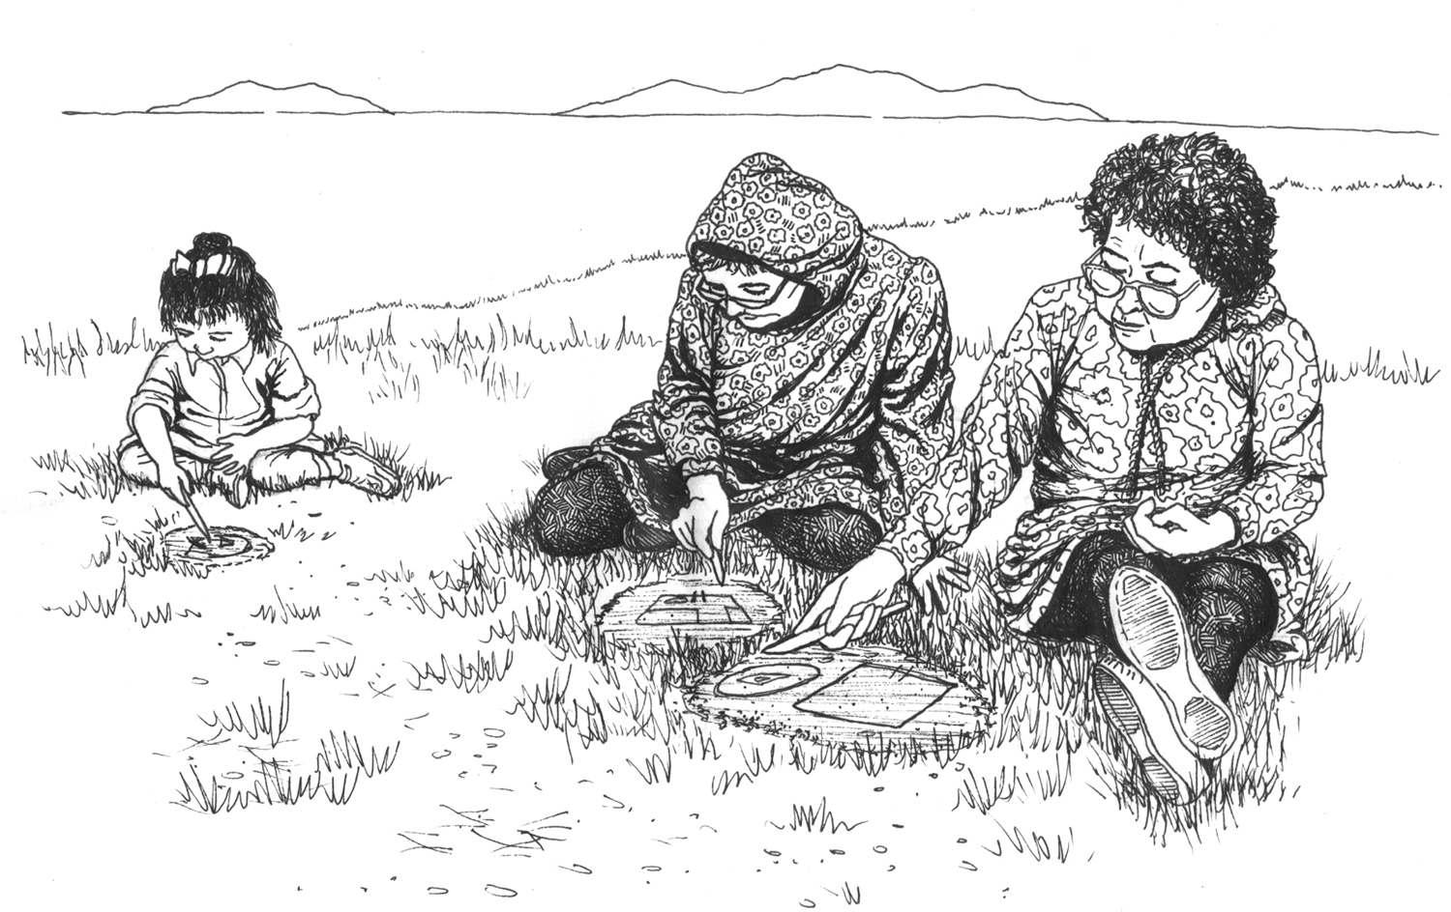
Figure 1: Women and a child story knifing

Years later, Yanez held a meeting with elders in Togiak to collect traditional stories that the project might be able to use to accompany the math modules. One of those stories was the story of an important Yup’ik figure, Iluvaktuq. Iluvaktuq is an epic hero whose family line embeds specific symbols on their parkas to identify their relationship to him.
Reminiscing about her childhood, Yanez mentioned that she would draw scenes and tell about the plot. Sometimes the children would ask each other a question, such as, “Where do you think Iluvaktuq was when he killed that giant caribou?” Then someone would use her story knife to draw that place. Through story knifing they would draw the parts of the parka and name each one. Adults would tell the children the Yup’ik names. That was how Yanez learned the names of the different pieces of the parka. For example, “this is how my parka would look, if I learned to make parkas.” (See Figure 2 below.)
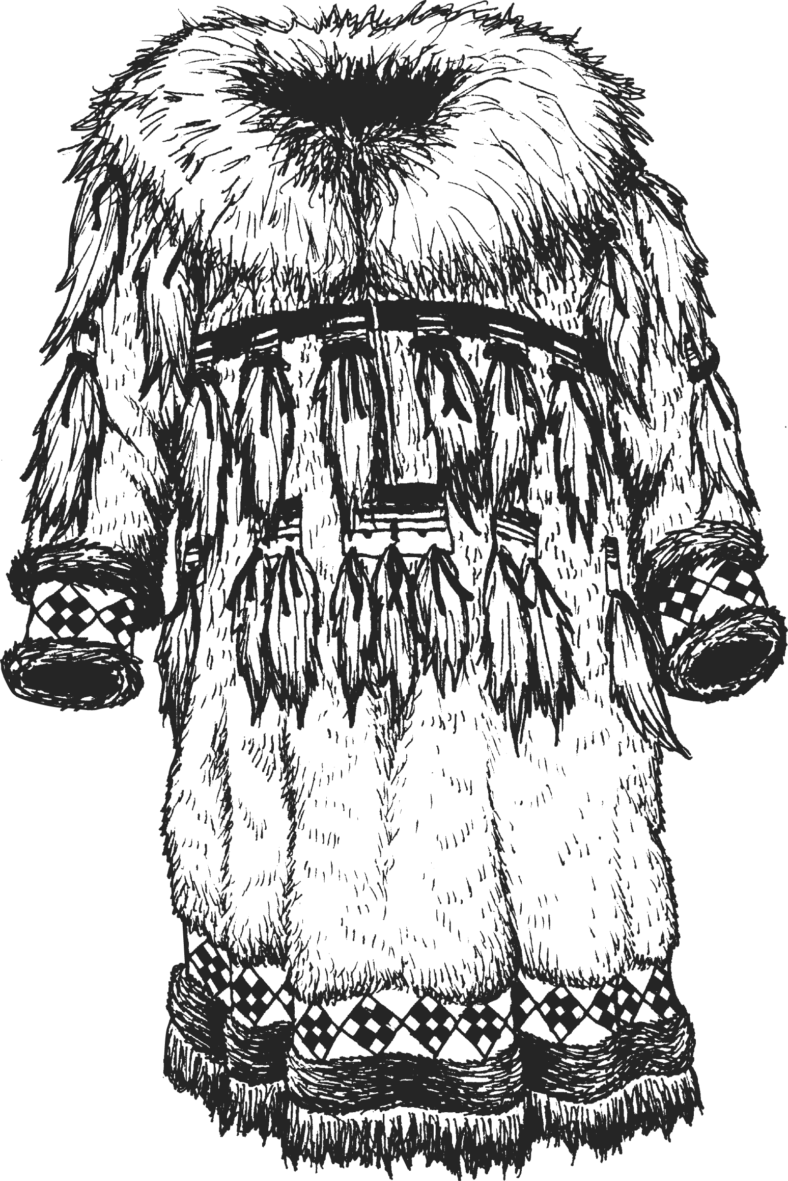
Figure 2: Parka showing parka designs

Because of the symbolism on parkas and because of the elaborate parka border patterns, we connected the story of Iluvaktuq to these two modules, Designing Patterns and Patterns and Parkas. Because of the inclusions of traditional, contextual, and embedded math stories in MCC, we have begun to develop Literacy Counts as a way to connect the teaching of mathematics to literacy. The purpose of this approach is to improve students’ math vocabulary, math concepts, and problem-solving skills through literacy. Joan Parker Webster, a University of Alaska Fairbanks faculty member and an MCC contributor, is spearheading this effort.

Making Patterns—Developing the Math of the Module

Lipka was aware of the connection between parkas, patterns, and traditional stories and was excited by the prospect of working with elders from St. Marys, Alaska, and their ways of making pattern pieces. A few years ago, while conducting a school in-service, he invited elders from the community to share their ways of making patterns. Years before, while working with the late Mary George of Akiachak, Alaska, and Marie Napoka of Tuluksak, Lipka collected common Yup’ik border patterns used to adorn women’s clothing and other objects.
Figure 3: Yup'ik Border Patterns

Winifred Beans of St. Mary’s, Alaska, is a Yup’ik elder who is known as a designer of fancy border patterns. It was obvious that when she made a rhombus from a rectangle, there was considerable mathematics involved. She makes her tumaqcat, or pattern pieces, by ﬁrst constructing a rectangle and then dividing it into a rhombus and four congruent right triangles. She carefully folds the rectangle into quarters (a smaller rectangle), then just as carefully cuts the quarter rectangle from one corner to another, making sure to cut across the center of the original rectangle so that it remains intact. When the result is unfolded, Mrs. Beans has made a rhombus and four congruent right triangles (Figure 4).
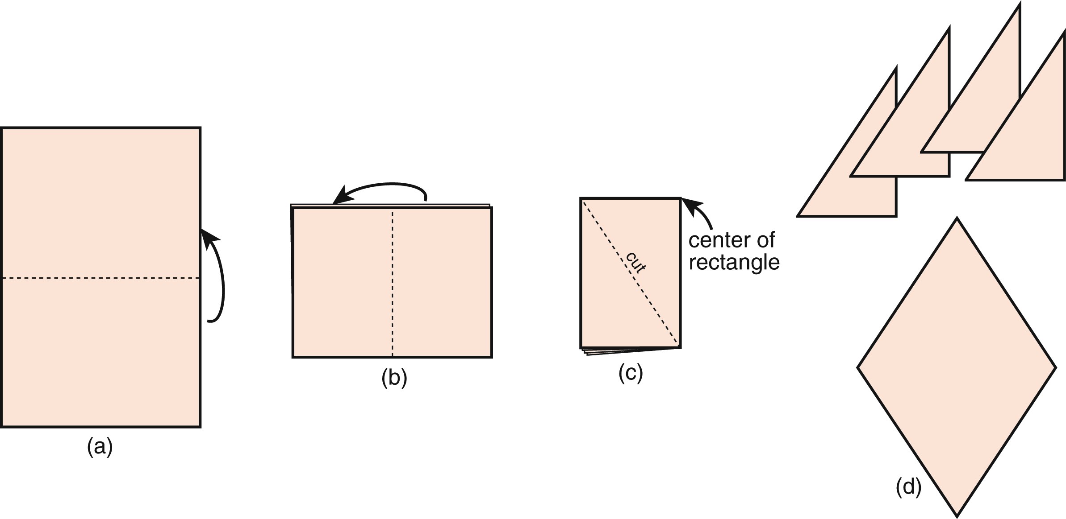
Figure 4: Winifred Beans’ method of making a rhombus from a rectangle

She taught us her way of making a rhombus by having us observe her and trying to make these pieces when we were ready. Working with Mary Beans, her daughter who also resides in St. Marys, helped to clarify Mrs. Beans’ method. On the plane ride home, Lipka outlined some of the mathematics involved in what Mrs. Beans demonstrated.
A rhombus module should contain:
- Properties of a rhombus—it is a quadrilateral with four equal sides and opposite angles equal. Like a rectangle, a rhombus has two lines of symmetry. Unlike a rectangle, these go from vertex to vertex, rather than through the midpoints of the sides.
- Geometrical and area relationships—a rhombus is half the area of the rectangle from which it was formed
- Composing and decomposing geometric shapes
- Symmetry and congruence
- How symmetry in Western math differs from Yup’ik design
Yup’ik Design Principles
Yup’ik pattern-makers use rectangles, squares, rhombi, and right triangles in different sizes to create a variety of interesting symmetrical patterns similar to linear frieze patterns. They use shapes of two contrasting colors to produce visually pleasing effects. The shapes derived from rectangles or squares ﬁt together in several different ways. This allows people to make many different patterns using the same basic shapes. A few examples are shown in Figure 5.
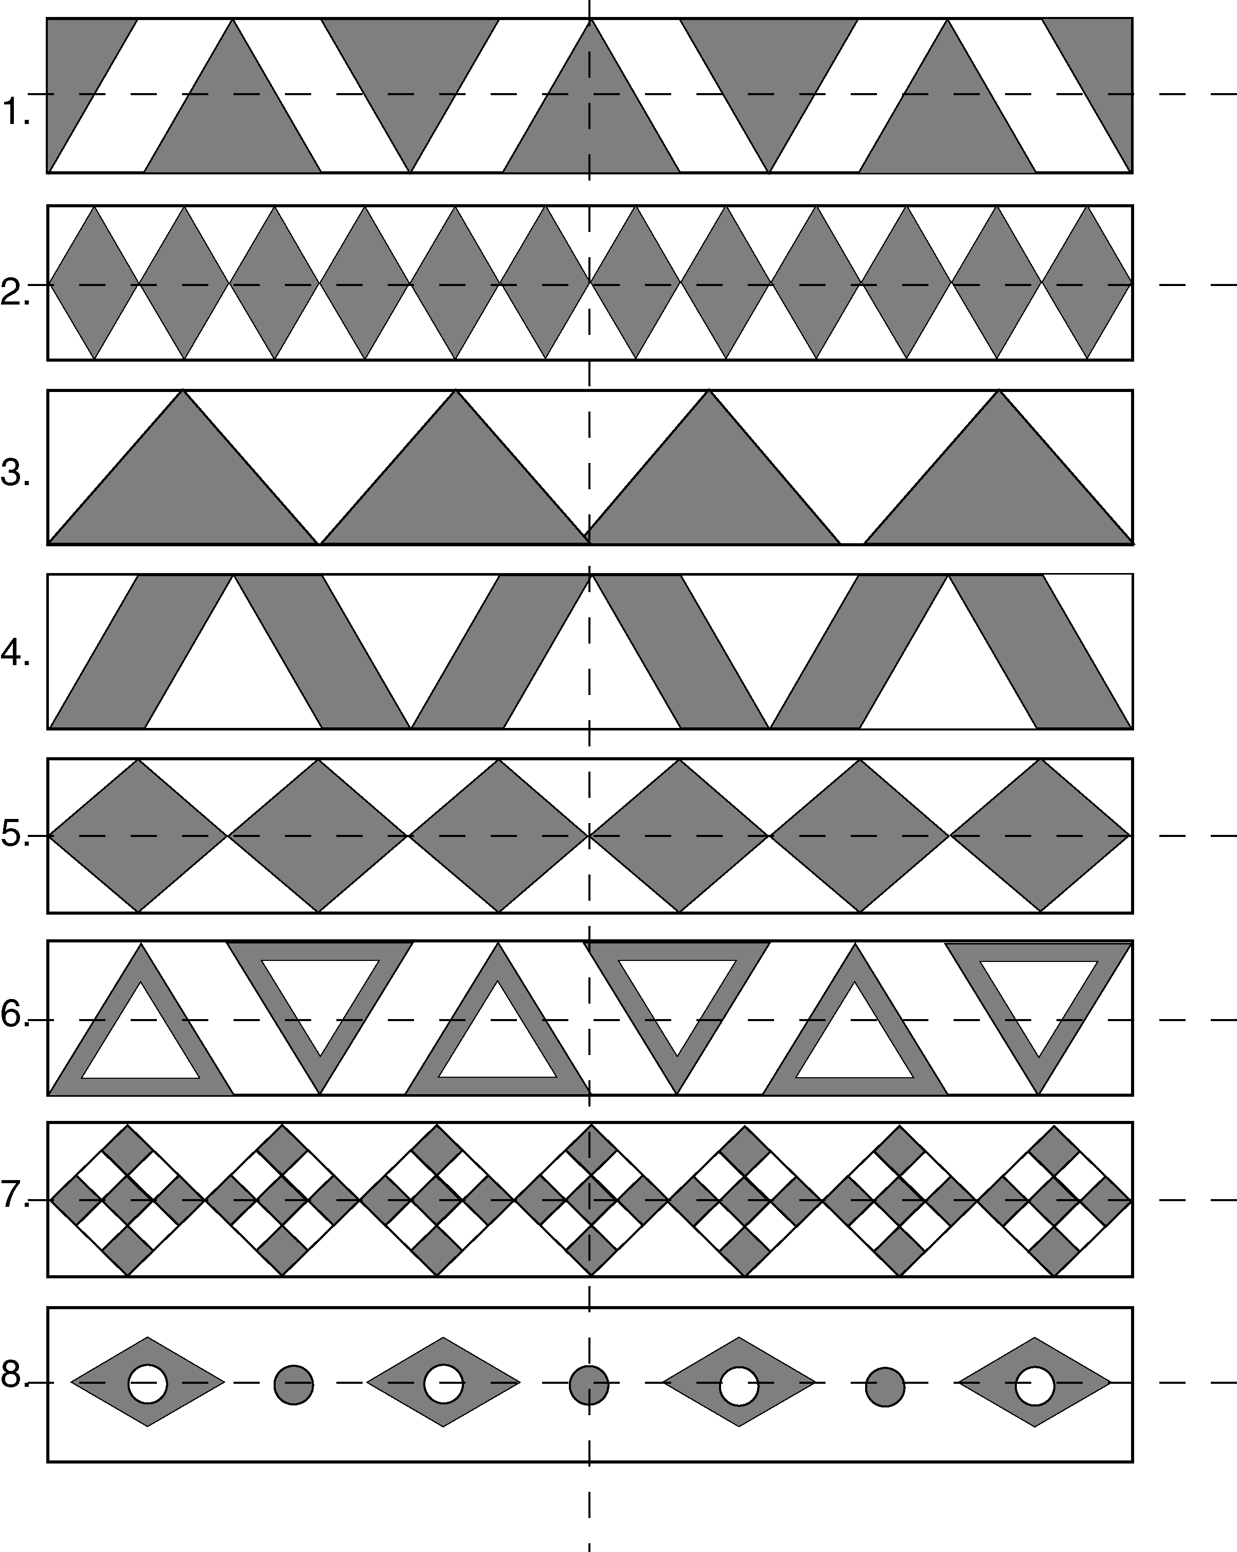
Figure 5: Repeating linear patterns

Symmetrical Linear Patterns and Basic Repeating Elements
Yup’ik designers use linear patterns for parka borders (parka bottoms and sleeves), headbands, and boots. These patterns all follow a few rules (these rules were explained by Theresa Mike, a Yup’ik elder from St. Marys):
• Start with a basic combination of shapes in contrasting colors. This becomes the basic repeating element; these shape combinations are usually arranged so that shapes line up edge to edge.
• The basic repeating elements are repeated over and over in a linear sequence to complete the pattern.
• Each pattern has a “balance point” at the center, with an equal number of design elements on either side of the balance point.
• Usually (but not always) the balance point is a line of symmetry for the entire shape.
Mathematically, a repeating linear pattern could continue forever. However, a practical pattern has a beginning and ending edge. These edges may be constructed using only part of the basic repeating element in order to end with the edge vertical. Headband patterns usually end in such a way that the pattern would be continuous if one edge could wrap around to meet the other. Making linear patterns is part of the Designing Patterns module, and the practical problems of how you make your starting piece and ending piece match up become a component of this module.
To more fully understand how Yup’ik linear patterns and balance differ from Western concepts of symmetry, we worked with elders, Yanez, and Andrew-Irhke. Yanez stated:
We don’t make patterns like this [Figure 6 below] because they do not have meaning. Patterns are named after things that they resemble. For example, the pretend mountains resemble mountains, and the braid resembles braids, etc. Traditionally we didn’t use the trapezoid shape. Also, this pattern lacks balance between white and dark. The small dark shapes are out of balance with the white larger trapezoids. Aesthetically, this is not pleasing to a Yupiaq eye.

Figure 6: A linear pattern that lacks balance and meaning

Summer Math Institute—A Two-Way Process
Each summer for the last four years, we have conducted a Summer Math Institute (SMI) in Fairbanks, Alaska, to provide mathematical, pedagogical, and cultural support for teachers who use MCC modules. Last summer, we choose to organize the SMI around the Designing Patterns module; the module at that time was complete and we were using to prepare the teachers to use..To strengthen the cultural component of SMI, we invited Theresa Mike, Elias Polty, and Lilly Afcan from St. Marys to join Yanez and Ihrke and other cultural experts. In planning meetings led by Melissa Kagle, an MCC curriculum writer and faculty member, we decided that the major project of the SMI would be making a headband. The Yup’ik consultants, particularly those from St. Marys, suggested interweaving traditional Yup’ik song and dance and ending the SMI with a ceremony resembling traditional ceremonies, where each teacher would wear their headdress and dance. All headdresses would be made following the design principles mentioned earlier. Thus, we began to integrate and recontextualize the module based on these ideas. At the meeting, we gained more insights into some of the design principles that Theresa Mike explained and demonstrated to us. Further, Ihrke showed us how she makes a circle from a square because of the symbolic importance of circles in Yup’ik cosmology and the circle motif can be included in the headdress. This is explained below. However, because of this knowledge This required major revisions in the development of the module were required.. During the fall and spring of 2005 and 2006, SMI teachers have piloted Designing Patterns.

Deepening the Cultural and Mathematical Connections of the Module
Yanez and Ihrke, aware of regional differences between St. Marys and Bristol Bay, decided that module needed to include a traditional headdress from the Bristol Bay region as well. Irkhe had traveled to Germany a number of years ago and had the opportunity to visit the Museum Fur Volkerkunde in Berlin to see Yup’ik artifacts in their collection. Among them was a traditional Yup’ik headdress from the Bristol Bay region of Alaska. These cultural artifacts are no longer common. Below in Figure 7 is a picture of Irkhe wearing a headdress she recently made.
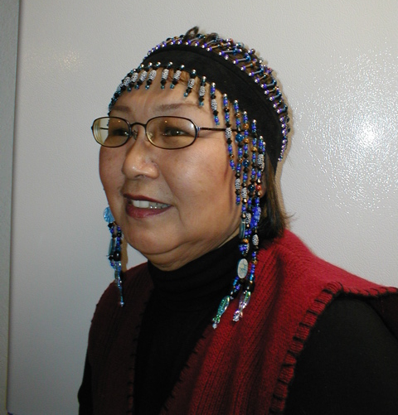
Figure 7: Dora Andrew-Ihrke wearing a traditional Bristol Bay headdress

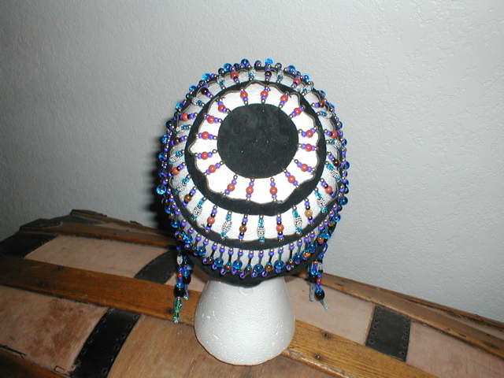
Figure 8: Importance of circular strips in a headdress

When Ihrke worked for Dillingham City Schools, she asked the elders if she could use their knowledge for teaching and learning. The following was given to her by Elena Pat, an elder. She told Ihrke about the nacarrluk, the beaded headdress. To make the pattern for the circle, called the Nuna or earth, you begin with a square using the body measure of space between first and second knuckle of the index finger, which is at the top or crown of the head. This represents the earth, which is connected to the universe. Strips are then connected to the circle. These strips represent rings that encompass the stars, constellations and planets of the universe.
Use the body measure of the space between the first and second knuckle of your index finger as a way to measure. Measure two of these for the length and two for the width. Cut out a square that is this size. (See Figure 8 below.)
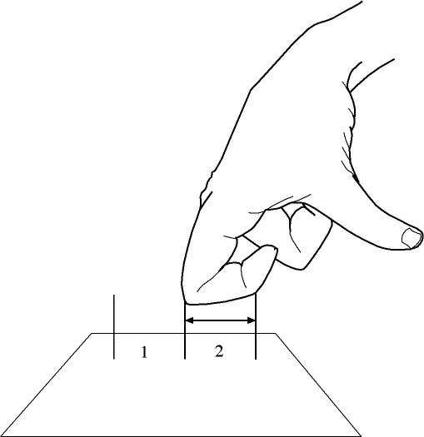
Figure 9: Body measure
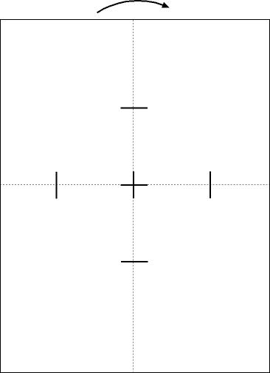
Next, locate the centerpoint of the square by folding it into quarters to form a smaller square.

Figure 10: Centerpoint

Cut a strip of paper the length of this smaller square. This becomes the template for the radius of your circle. Fold the square along its diagonals and open it up. Use your template to mark the distance from the center along each diagonal fold. Draw a straight line at each mark, perpendicular to the fold. Cut along each line to form an octagon (Figure 10). Use your scissors to round the edges (Figure 11).

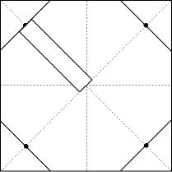
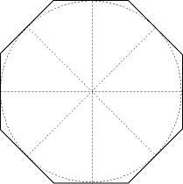

Figure 11: Template to make a circle Figure 12: Octagon

The number of the strips depends on the size of the beads. For example, if you have small beads you might three strips. And if you have larger beads you might have two strips. The space between the strips is measured by the index and the middle fingers. The bottom strip is measured right over the eyebrow, over the top of the ear around the back of the head. When Elena Pat measured her headdress with string, she started the measurement at the center of the forehead, positioned right over the eyebrow and top of the ear. She then proceeded measuring with the string in a right-to-left direction around the head, until the string met again at the center. This formed the bottom strip. The second strip was measured the same way, but three fingers apart from the bottom.
This last addition to the module both increased and deepened the potential mathematical and cultural content.
Putting all the Pieces Together in the Making of a Module
The center piece of the Designing Patterns module is making a rhombus from a rectangle. We unpacked the mathematics of this process to make the geometrical relationship between the rhombus and the rectangle from which it was derived. The elders’ use of lines of symmetry, congruence, midpoints, and diagonals lays the foundation for the math of the module. Further, the ways in which elders teach others to make such patterns became a key component of the pedagogy of the module—expert-apprentice modeling, joint productive activity, and cognitive apprenticeship. We realized the connection between literacy and parka patterns when we were told the story of Iluvaktuq and how modern parka patterns include a symbol to show a familial relationship. Therefore, the module contained both math and literacy. Ihrke deepened both the cultural and mathematical connections by showing us, telling us, and demonstrating how to make a traditional Bristol Bay headdress. This revealed deeper cultural knowledge about Yup’ik cosmology as well as how to make a circle out of a square and the mathematics involved in that process. We included the making of a headdress as a key project in the module, based on the guidance of elders and community members who worked with us in last year’s SMI. In addition, a community group that we work with in St. Marys created songs and dances having to do with this module and other stories collected by the project. In honoring MCC, the community of St. Marys is presenting songs and dances originally told by Annie Blue.
Conclusion
This brief paper begins to outline the complex relationship between insiders and outsiders and how we have worked together over many years to create school math that is contextualized in culturally familiar ways. Further, the project works collaboratively with community members, elders, Yup’ik teachers and consultants, and math educators and mathematicians until we are able to create a math module that represents both the standards of the people we work with and state and national math standards. The project has only compared students’ math knowledge (treatment vs. control groups). The approach that we have taken underrepresents the strength of the modules and what students learn. However, what this paper emphasizes is the importance of a two-way collaborative process between groups of unlikely partners, the university and communities, resulting in a creative, culturally responsive, and rigorous math curriculum for elementary school students. This partnership has also resulted in closing the perennial academic gap. Clearly, this approach can be used by ethnomathematicians and communities elsewhere.

References
Deyhle, D., & Swisher, K. (1997). Research in American Indian and Alaska Native education: from assimilation to self-determination. In M. W. Apple (Ed.), Review of research in education (Vol. 22, pp. 113-194). Washington: American Educational Research Association.
Institute for Government Research. (1928). The problem of Indian administration (Report of a survey made at the request of Honorable Hubert Work, Secretary of the Interior, and submitted to him, February 21, 1928). Baltimore: Johns Hopkins Press. (Reprint, 1971, New York: Johnson Reprint; also known as the Meriam Report.)
Lipka, J. (1994). Culturally negotiated schooling: Toward a Yup'ik mathematics. Journal of American Indian Education, 33(3), 14-30.
Pendergrast, S., Jerry Lipka, Dan L.Watt, and Kay Gilliland (2006 draft). Patterns and Parkas: Investigating Geometric Principles, Estimation, Angles, and Patterns. Fairbanks, Alaska: Math in a Cultural Context, School of Education, University of Alaska Fairbanks.
Watt, Dan L., Jerry Lipka, Joan Parker Webster, Evelyn Yanez, Dora Andrew-Ihrke, and Aishath Shehenaz Adam (2006). Designing Patterns: Exploring Shapes and Area. Calgary, Alberta: Detselig Enterprises Ltd.

Math in a Cultural Context has been supported by grants from the U.S. Department of Education entitled Developing and Implementing Culturally Based Curriculum and Teacher Preparation, under award #S356A030033 and the National Science Foundation, entitled Improving Alaska Native Elementary Students’ Math Performance, under award EESI-0138920. The findings and opinions reported herein do not necessarily reflect those of NSF or the U.S. Department of Education.
Dan Watt, a consultant to the project, explained this difference after observing Theresa Mike, an elder from St. Marys, Alaska demonstrate her way putting pattern pieces together to make a pleasing design. Dan Watt, Evelyn Yanez, Dora Andrew-Ihrke, and Lilly Afcan all worked together to come this understanding.

